# SDN in Docker - Project Report

## Team Members:

Vivek Nagalapura Ravindra

Amith Kumar Matapady

## Problem Statement:

To set-up a connection between two host each with docker container(s) using Open vSwitch and install OpenDaylight and its features.

## Introduction:

### Docker:

Docker is a set of platform as a service (PaaS) products that uses OS-level virtualization to deliver software in packages called containers. Containers are isolated from one another and bundle their own software, libraries and configuration files; they can communicate with each other through well-defined channels.

### Open vSwitch:

Open vSwitch is an open-source implementation of a distributed virtual multilayer switch. br-int is the default name for the core bridge used on compute and network nodes.

### Generic Routing Encapsulation:

Generic Routing Encapsulation (GRE) is a communication protocol used to establish a direct, point-to-point connection between network nodes.

### OpenDaylight:

OpenDaylight (ODL) is a modular open platform for customizing and automating networks of any size and scale. In this project, we are going to launch OpenDaylight in Docker. We are using the docker version of OpenDaylight Carbon built on 26 May 2017.

### Virtual Ethernet Device:

The virtual Ethernet devices (or veth devices) is a local ethernet tunnel. They can act as tunnels between network namespaces to create a bridge to a physical network device in another namespace, but can also be used as standalone network devices.

### Linux Bridge:

Linux bridge is a layer 2 virtual device that on its own cannot receive or transmit anything unless you bind one or more real devices to it.

### Wireshark:

Wireshark is a free and open-source packet analyzer. It is used for network troubleshooting, analysis, software and communications protocol development, and education.

## Implementation:

### Installations:

We have instances of Ubuntu running on two Virtual Machines. These act as our host machines.

The below software were installed for this project. The Open vSwitch and Docker need to be installed on both the host machines. Rest of them need to be installed on at least one of them (all of these need to available on a single system).

1. 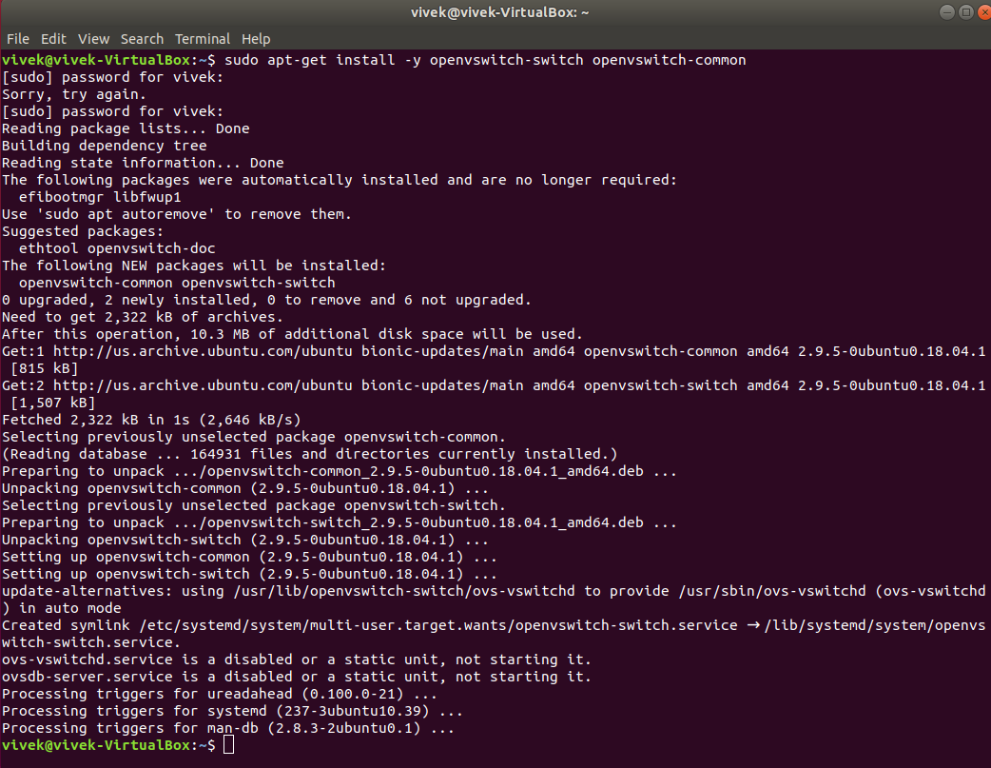Open VSwitch
2. Docker

1. A screenshot of a computer

   Description automatically generatedJava Development Kit(JDK) 11
2. OpenDaylight

1. A screenshot of a computer

   Description automatically generatedWireshark

### Connect docker using OVS bridge:

We connect the docker to one of the virtual ethernet device pair and the other device to the Open vSwitch bridge br-int (the core bridge).

Steps:

1. Run the docker container running CentOS on both the host machines and get the IP Addresses. We found that that both the containers have the same IP Address. So we ran another container and killed the first one on one of the host machines.

1. Then we tried to ping the other container (in the other host) from this container and found that the destination was unreachable.

1. We started setting up the OVS bridge to establish the connection between the 2 containers on different hosts.

1. After setting up the bridge, we were able to ping from one container to the other.

### Wireshark:

We pinged from one container to another and checked the traffic on Wireshark.

### Open Daylight Feature Install:

We installed the OpenDaylight features and tested the mininet topology in this container.

## Challenges Faced

* Main hurdle was learning Docker and containerization of applications.
* Creating 2 heavy weight VMs on the same laptop machine was a challenge since we have limited processing power.
* Containers on different hosts had the same IP Addresses, so we had to respawn another to get a different IP on one of them.
* Issues with JAVA versions: Initially we had JDK 8 installed, but an upgrade changed it to JDK 11 but JAVA_HOME variable was still pointing to JDK 8 path which had become invalid. Figuring out that the JDK had upgraded took us some time since the Open Daylight was failing to launch.
* Initially we had installed OpenDaylight Boron which did not have the dluxapps features. After figuring out the list of features that were available in Boron, we switched to Carbon. During this, we faced issues with docker images not stopping, we had to stop the images forcefully before we were able to switch to Carbon. Also when we re-started the container, SSH into the container didn’t work as the host key had changed. So we had to generate and save the new SSH key.

## Conclusion:

Docker is a easy and efficient way to build and deploy any application. We were successful in setting up a communication channel between 2 docker containers on different host machines using Open vSwitch. We were able to use a containerized OpenDaylight-Carbon to display the topology of a Mininet running on a separate VM.

## References:

[1] <https://en.wikipedia.org/wiki/Docker_(software)>

[2] <https://en.wikipedia.org/wiki/Open_vSwitch>

[3] <https://www.imperva.com/blog/what-is-gre-tunnel/>

[4] <https://hub.docker.com/r/yurekten/odl-carbon/>

[5] <https://goyalankit.com/blog/linux-bridge>

[6] <http://man7.org/linux/man-pages/man4/veth.4.html>

[7] <https://en.wikipedia.org/wiki/Wireshark>

[8] <https://app.box.com/s/t4yob7umn1m88b4p4vmbeu1scelee31e/folder/63985323299>